Writing Numbers in Spanish
Español dos

0
1
2
3
4
5
6
7
8
9
10
11
12
13
14
15
16
17
18
19
20
30
40
50
60
70
80
90
100
101
186
200
300
400
500
600
700
800
900
1003
1432
2011
15.895
155.671
1.000.000
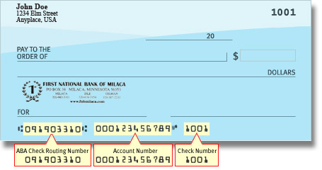
2.000.000

